*RMBL Phenology Demography Metadata (RPD)*

Protocol and metadata for establishing and monitoring flowering in *Delphinium nuttallianum, Lupinus bakeri*, and *Erigeron speciosus* demography populations:

**Written by**: Rebecca M. Dalton (postdoc), Nora Underwood (PI), and Brian Inouye (PI)

**Last updated**: 3 May 2022 by Rebecca M. Prather

**Photos**: R. Dalton, B. Inouye, D. Inouye, A. Turner, and Xingwen Loy; **Figures**: R. Dalton, R. Prather

*All files associated with this project begin with the code* ***RPD***: “RPD_FILENAME_date.docx/xlsx” Please continue to use this format.

The code, RPD, is short for the project name (**R**MBL **P**henology **D**emography).

**Table of Contents:**

Background and goals 2

Project history 3

Data access 3

Researchers who collected field data: (update each year) 3

Publications 3

Peer-reviewed publications 3

Conferences: 3

REU project abstracts 3

Transect locations 5

Field methods 6

Tools/supplies needed 6

Setting up demographic transects (2019) 6

Demographic census 10

Recording phenology 16

How to record data 19

Create a new data sheet 19

Data input 20

Maps of transects 21

Metadata 32

Demography metadata 32

Phenology metadata 38

Equations relating plant size to biomass 41

Data anomalies and notes 44

Lupinus bakeri 44

Delphinium nuttallianum 46

Erigeron speciosus 47

# *Background and goals:*

In response to early snowmelt, some flowering species are shifting bloom time (flowering phenology). Unfortunately, we have limited knowledge about the relationship between flowering phenology and lifetime fitness, which would allow us to accurately quantify the ecological and evolutionary consequences of these shifts. Therefore, the goals of this study are to (1) quantify selection on flowering time, (2) assess how within- season synchrony in flowering affects fitness, (3) characterize phenological responsiveness to climate, and (4) determine the sensitivity of population growth rate to shifts in flowering phenology.

1. What is the strength of phenotypic selection on flowering time? Phenotypic selection on flowering phenology may vary from year to year depending on abiotic and biotic conditions. For example, if selection by the environment, such as spring frost events, and seed-predators occurs in opposite directions, the optimal flowering time for a species may be a compromise between last frost date and avoidance of seed predators. Unfortunately, we have limited knowledge about the relationship between flowering phenology and lifetime fitness. Therefore, with these data, we will be able to accurately quantify selection on flowering time.
2. How does synchrony in flowering affect fitness? Synchronous flowering, or mass flowering of individuals in a population, may be extremely important for fitness. For example, if flowering is highly synchronous, the number of flowers may attract more pollinators and potentially result in higher reproductive success. If early snowmelt conditions result in less synchronous flowering, reproductive fitness may suffer if there are not enough pollinators. With the data from this study, we will be able to measure the importance of synchronous flowering to reproductive success.
3. What are individual reaction norms for flowering? Determining the extent to which phenological shifts influence ecological outcomes requires first characterizing the extent of change in phenology and then relating change in phenology to ecological responses such as a change in performance, abundance or productivity. The strength of a phenological response to climate for an individual, a population, or a species is often described as its "sensitivity", or the slope of the norm of reaction of phenology across climate environments (B. Inouye et al. 2019). From the data in this project, we will be able to calculate individual reaction norms.
4. How sensitive is population growth rate to flowering phenology? One of the greatest challenges in ecology is predicting how species will persist under climate change. One approach is to assess how changes in environmental drivers directly affect demographic responses of populations. With these data, we can quantify how sensitive population growth rate is to changes in flowering phenology.

# *Project history:*

Nora Underwood and Brian Inouye initiated this study in 2019 with the help of Rebecca Dalton (postdoc), Alyssa Turner (REU), and Ashley Woolman (RA). They established transects, tagged approximately 150 plants of each species, and conducted a demographic census. Unfortunately, they missed collecting size information for *Delphinium nuttallianum* in 2019.

# *Data access:*

Data and R scripts for this project are stored at Open Science Framework. You may view the folders associated with this project at the link below, but you must request access from Brian Inouye, Nora Underwood, or David Inouye to make edits.

# *Researchers who collected field data: (update each year)*

* + 2022:
  + 2021: Brian Inouye (BI), PI [(binouye@bio.fsu.edu);](mailto:(binouye@bio.fsu.edu) Nora Underwood (NU), PI [(nunderwood@bio.fsu.edu);](mailto:(nunderwood@bio.fsu.edu) Rebecca Prather (RP), postdoc [(rprather2@fsu.edu);](mailto:(rprather2@fsu.edu) Rebecca Hayes (RH, RAH), phenology RA [(hayes.rebeccaanne@gmail.com);](mailto:(hayes.rebeccaanne@gmail.com) David McNutt, RET [(dwmcnutt@gmail.com);](mailto:(dwmcnutt@gmail.com) Rhyne Gulley, RET [(rhyne_gulley@dpsnc.net);](mailto:(rhyne_gulley@dpsnc.net) Sahalie Pittman, REU [(spittman@middlebury.edu)](mailto:(spittman@middlebury.edu)
  + 2020: Brian Inouye (BI), PI [(binouye@bio.fsu.edu);](mailto:(binouye@bio.fsu.edu) Nora Underwood (NU), PI [(nunderwood@bio.fsu.edu);](mailto:(nunderwood@bio.fsu.edu) Fatima Alcantara (FA), phenology RA [(falcantav@gmail.com);](mailto:(falcantav@gmail.com) Rebecca Hayes (RH, RAH), phenology RA [(hayes.rebeccaanne@gmail.com);](mailto:(hayes.rebeccaanne@gmail.com) David McNutt, RET [(dwmcnutt@gmail.com);](mailto:(dwmcnutt@gmail.com) Hannah Souter (HS), REU [(hstouter@vassar.edu)](mailto:(hstouter@vassar.edu)
  + 2019: Rebecca Dalton (RD), postdoc [(rebeccadalt@gmail.com),](mailto:(rebeccadalt@gmail.com) Ashley Woolman (AW), phenology RA [(amwoolman@gmail.com),](mailto:(amwoolman@gmail.com) Alyssa Turner (AT), REU [(atac16@my.fsu.edu)](mailto:(atac16@my.fsu.edu)

# *Publications:*

## *Peer-reviewed publications:*

[none]

## *Conferences:*

[none]

## *REU project abstracts:*

1. Alyssa Turner (2019): Phenology, or the timing of biological events, are often sensitive to changes in abiotic factors. At the Rocky Mountain Biological Laboratory (RMBL), phenological events, such as first and last flowering, have shifted as a result of early snowmelt. Therefore, some species exhibit expanding flowering seasons. This could potentially impact synchrony, which is a measure of how many individuals are in bloom at the same time. I hypothesized that

synchrony indices would vary between individuals. To test this hypothesis, I recorded the phenology of tagged individuals of *Delphinium nuttallianum* and *Lupinus bakeri* at the Rocky Mountain Biological Laboratory (RMBL), CO. For these species, I calculated each individual’s synchrony index. I found that there is intraspecific variation in synchrony within these species. If the seasons of wildflowers shift to become more asynchronous, it is possible that these populations will decline.

# *Transect locations:*

* 1. *Delphinium nuttallianum*:
     1. Transect A:

1. 38.958639440, -106.988513641

2. 38.958656726, -106.988403904

3. 38.958664617, -106.988407033

4. 38.958646133, -106.988516589

* + 1. Transect B:

1. 38.958620065, -106.988518009

2. 38.958638885, -106.988409423

3. 38.958645925, -106.988410552

4. 38.958627954, -106.988520652

* 1. *Lupinus bakeri*:
     1. Transect A:

1. 38.955119851, -106.987905978

2. 38.955140619, -106.987797265

3. 38.955156935, -106.987801184

4. 38.955136349, -106.987908352

* + 1. Transect B:

1. 38.955130378, -106.987794451

2. 38.955114416, -106.987788896

3. 38.955093767, -106.987899052

4. 38.955109287, -106.987902442

* + 1. Transect C:

1. 38.955067044, -106.987889942

2. 38.955086500, -106.987782383

3. 38.955104174, -106.987787413

4. 38.955083286, -106.987895008

* + 1. Transect D:

1. 38.954980413, -106.987713620

2. 38.955066866, -106.987733809

3. 38.955063709, -106.987753362

4. 38.954976577, -106.987731566

* 1. *Erigeron speciosus*:
     1. Transect A:

1. 38.955446490, -106.989115313

2. 38.955507787, -106.989031796

3. 38.955513194, -106.989038320

4. 38.955452058, -106.989123081

* + 1. Transect B:

1. 38.955432865, -106.989099382

2. 38.955494253, -106.989017520

3. 38.955500355, -106.989023051

4. 38.955439328, -106.989107000

*Starting in 2020, *Erigeron speciosus* also measured in *Lupinus bakeri* plots A, C, & D

# *Field methods*

## *Tools/supplies needed:*

* 10m+ meter tape
* ruler
* meterstick
* clipboards and data sheets
* pencils
* aluminum tags and nails
* paint pens
* string
* cut PVC pipe (for transect ends)

## *Setting up demographic transects (2019):*

1. In 2019, we located areas near the phenology plots with a fairly high density of *Erigeron speciosus* or *Lupinus bakeri.* We used David Inouye’s *Delphinium nuttallianum* transects established in the center of the Gothic townsite.
2. Once we found these areas, we outlined transects by driving cut pieces of PVC pipe into the ground at one edge and extended a meter tape for 10 meters.
3. We started walking along the tape and searched for every single *D. nuttallianum*,

*L. bakeri*, or *E. speciosus* plant within 100 cm south of the tape (for *L. bakeri* only, transects are 200 cm wide because plants often spread greater than 100 cm). We included all plants that are have more than half of their vegetation within the transect lines. We tagged all vegetative and reproductive plants (Figure 1).

1. We marked each plant with an aluminum tag held in place with a small nail pushed into the soil. Each aluminum tag had a unique number, beginning with 1 (Figure 2A). For consistency, we placed the nail and the tag 5cm to the north and 5cm to the east side of the plant.

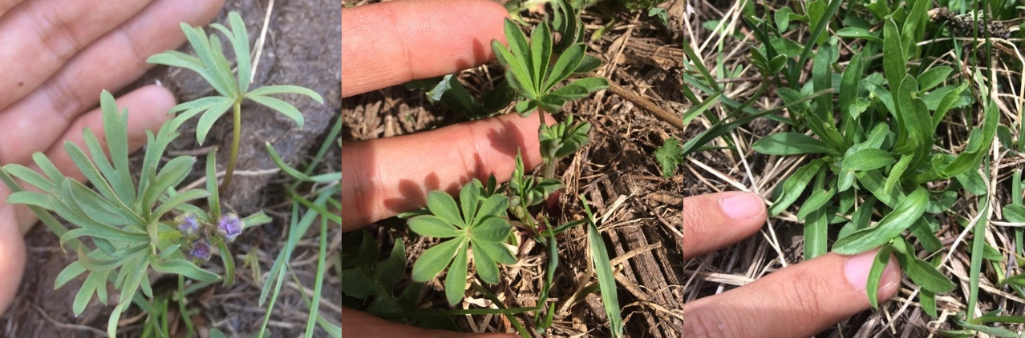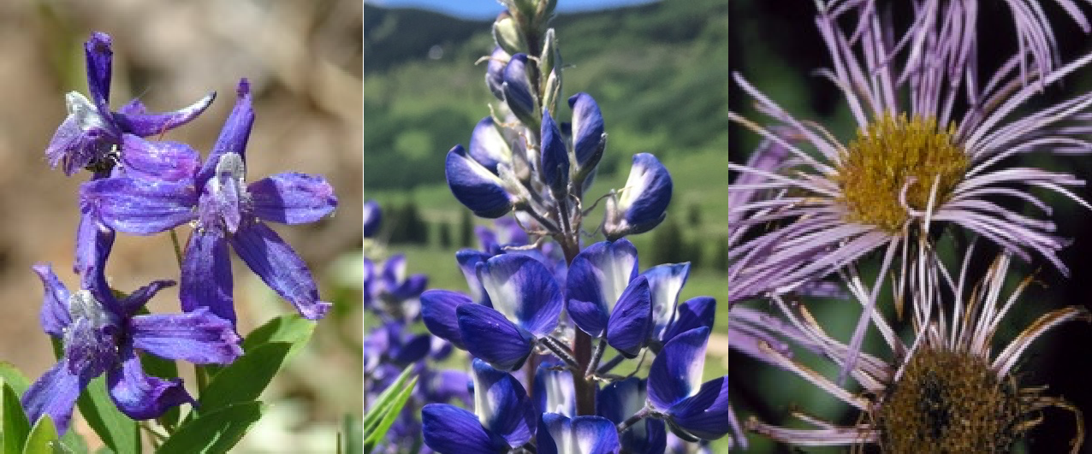

A) *Delphinium B) Lupinus C) Erigeron*

**Figure 1.** Leaves and flowers of study species, A) *Delphinium nuttallianum*, B)

*Lupinus bakeri*, and C) *Erigeron speciosus.*

1. The high density of small *D. nuttallianum* plants made it difficult to mark with aluminum tags alone, and therefore we used plastic colored cocktail toothpicks (https://spparties.com/collections/factory-direct-products/products/4-aces-1) to differentiate between multiple plants marked by a single tag. There was often more than one *D. nuttallianum* plant associated with each aluminum tag, and they are differentiated by toothpick color and shape (Figure 2B). Starting in 2020, toothpicks were also used in the *L. bakeri* plots to tag some seedlings.

### Color codes for toothpicks:

* + 1. Red = R
    2. Orange = O
    3. Yellow = Y
    4. Green = G
    5. Blue = B
    6. White = W

### Shape codes for toothpicks:

* + 1. Hearts = H
    2. Clubs = C
    3. Diamonds = D
    4. Spades = S
    5. Other = B

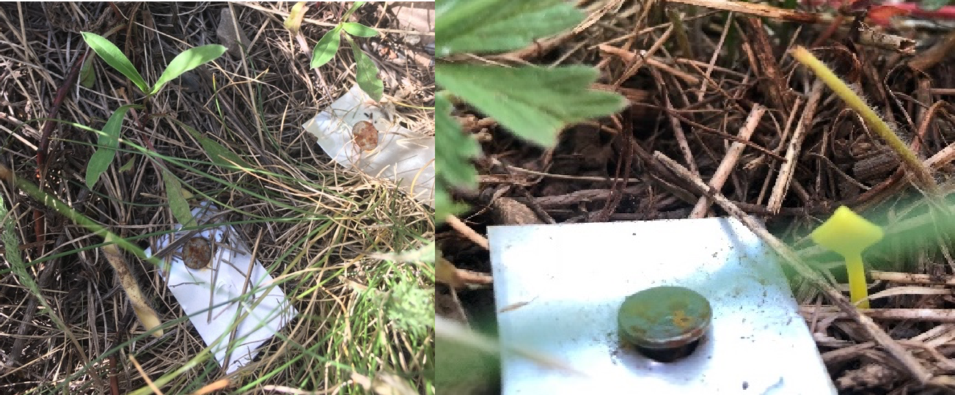

A)

B)

**Figure 2.** A) Two plant tags mark two *Erigeron speciosus* plants. B) Close up of an aluminum tag and plastic cocktail toothpick marking a *Delphinium nuttallianum* plant. This plant would be identified as 61YD (the number on the aluminum tag is 61 and the tag is a yellow diamond, YD)

1. 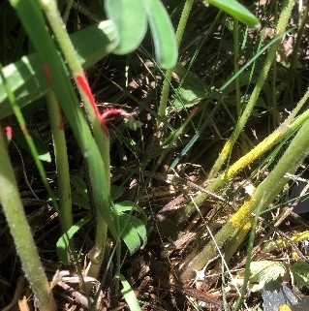When we marked *Lupinus bakeri* plants with the aluminum tags early in the season, they were very easy to tell apart. As plants grew larger, we found it was hard to keep track of individual plants. Although each plant was tagged with a unique aluminum tag, we additionally painted the stems of plants close to one another with different colors (Figure 3). This better allowed us to collect consistent phenology data (see steps for this later in the protocol).

**Figure 3.** Two *Lupinus bakeri* plants growing close to one another. We felt for separation between the stems and colored each plant with a different color, either pink or yellow in this example.

1. In 2020, a frost killed buds of many *E. speciosus* in their original demography plots so new *E. speciosus* plants were tagged within the *L. bakeri* plots. The *E. speciosus* plants in those plots are encircled with twine as it can be difficult to differentiate clumps. Additionally, *E. speciosus* plants within the *L. bakeri* plots have their aluminum tags located in the center of each clump with an “E” before the number.
2. We recorded the X (position along the tape in cm, east to west) and Y (distance from the bottom of the tape, north to south) coordinates of the plant (Figure 4).

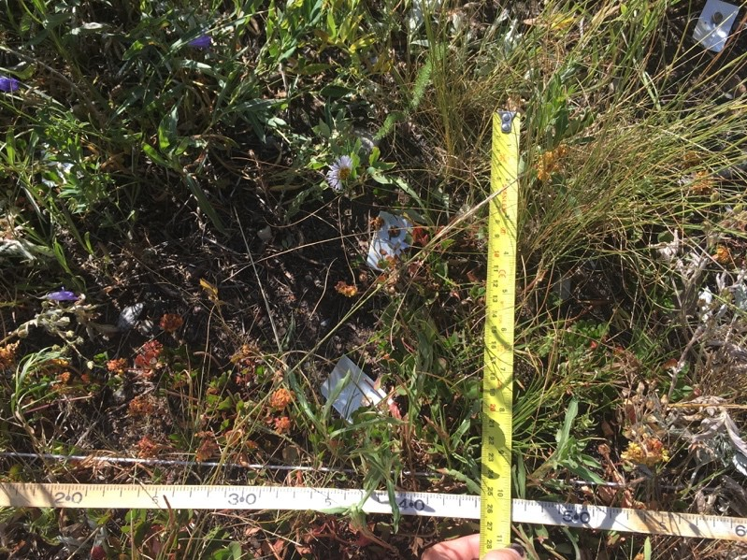

**Figure 4.** We recorded the X- and Y-location of the center of each plant. For this

*Erigeron speciosus*, the plant is approximately located at X=45 cm and Y=26 cm.

1. We tried to mark approximately 150 plants per species. This required setting up a few transects depending on plant density. Since we had more than one transect for all species, we labeled the PVC pipe marking each transect with permanent marker. We have two transects (A and B), which are parallel and approximately 2 meters apart from one another For *Erigeron speciosus* and *Delphinium nuttallianum* (Figure 5). We have a total of four transects (A – D) for *L. bakeri.* Transects A – C are parallel, while D is perpendicular to those transects (Figure 5).

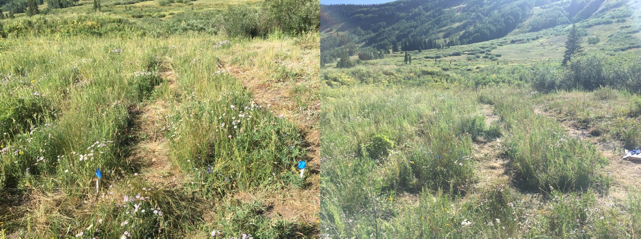

Transect B

Transect A

Transect

Transect C

Transect B

A

A) *Erigeron* B) *Lupinus*

**Figure 5.** Transects of A) *Erigeron speciosus* and B) *Lupinus bakeri*. Please note that Transect D is out of the field of view for *L. bakeri.*

## *Demographic census:*

1. The demographic census occurs one time every year. This includes collecting the following data: scoring survivorship, quantifying recruitment, and recording plant size and reproductive success This census can usually occur once most of the reproductive plants set fruit.
   * **\*NOTE\***: Do not wait until *D. nuttallianum* begins to set fruit before beginning the census, as the vegetation begins to senesce before the plant has fully formed fruits. In 2019, we missed recording size on all reproductive and non-reproductive plants.
2. ***Scoring survivorship:*** Record “1” under survivorship if a tagged individual survived the winter. Do not remove the aluminum tag during the first year that you don’t see a plant, as these long-lived plants may go dormant. Wait until the second year of not seeing a plant before removing the tag.
3. ***Tag new individuals*** (for quantifying recruitment): Start by walking along the tape and searched for every single untagged plant within each transect. Make sure to include all plants that are have more than half of their vegetation within the transect lines. Mark each new plant with an aluminum tag held in place with a small nail pushed into the soil. Give each aluminum tag a unique number. For most individuals this will begin with the last number + 1 from the previous census. However, within the *D. nuttallianum* demography plots, some seedlings are not given a completely new number but rather a new toothpick (see above for description). For consistency, we placed the nail and the tag 5cm to the north and 5cm to the east side of the plant. Record the transect and X, Y, location of the new plant.
   * **To quantify recruitment,** calculate recruitment by dividing the total number of fruits produced in year *t-1*/ the number of new seedlings in year *t* for each transect.
4. ***Record plant size*** of each tagged individual using a ruler or a meter stick. For the relationship between plant size and aboveground biomass for each species, see “Erigeron speciosus LUBA Transects (2021)

*Measuring size of Delphinium nuttallianum* (**Figure 6**):

* Total number of basal leaves
* Length of the largest basal leaf (cm)
* Total number of inflorescences: 0 if plant is non-reproductive
* Height of the tallest inflorescence (cm) (from the ground to the base of the uppermost flower)

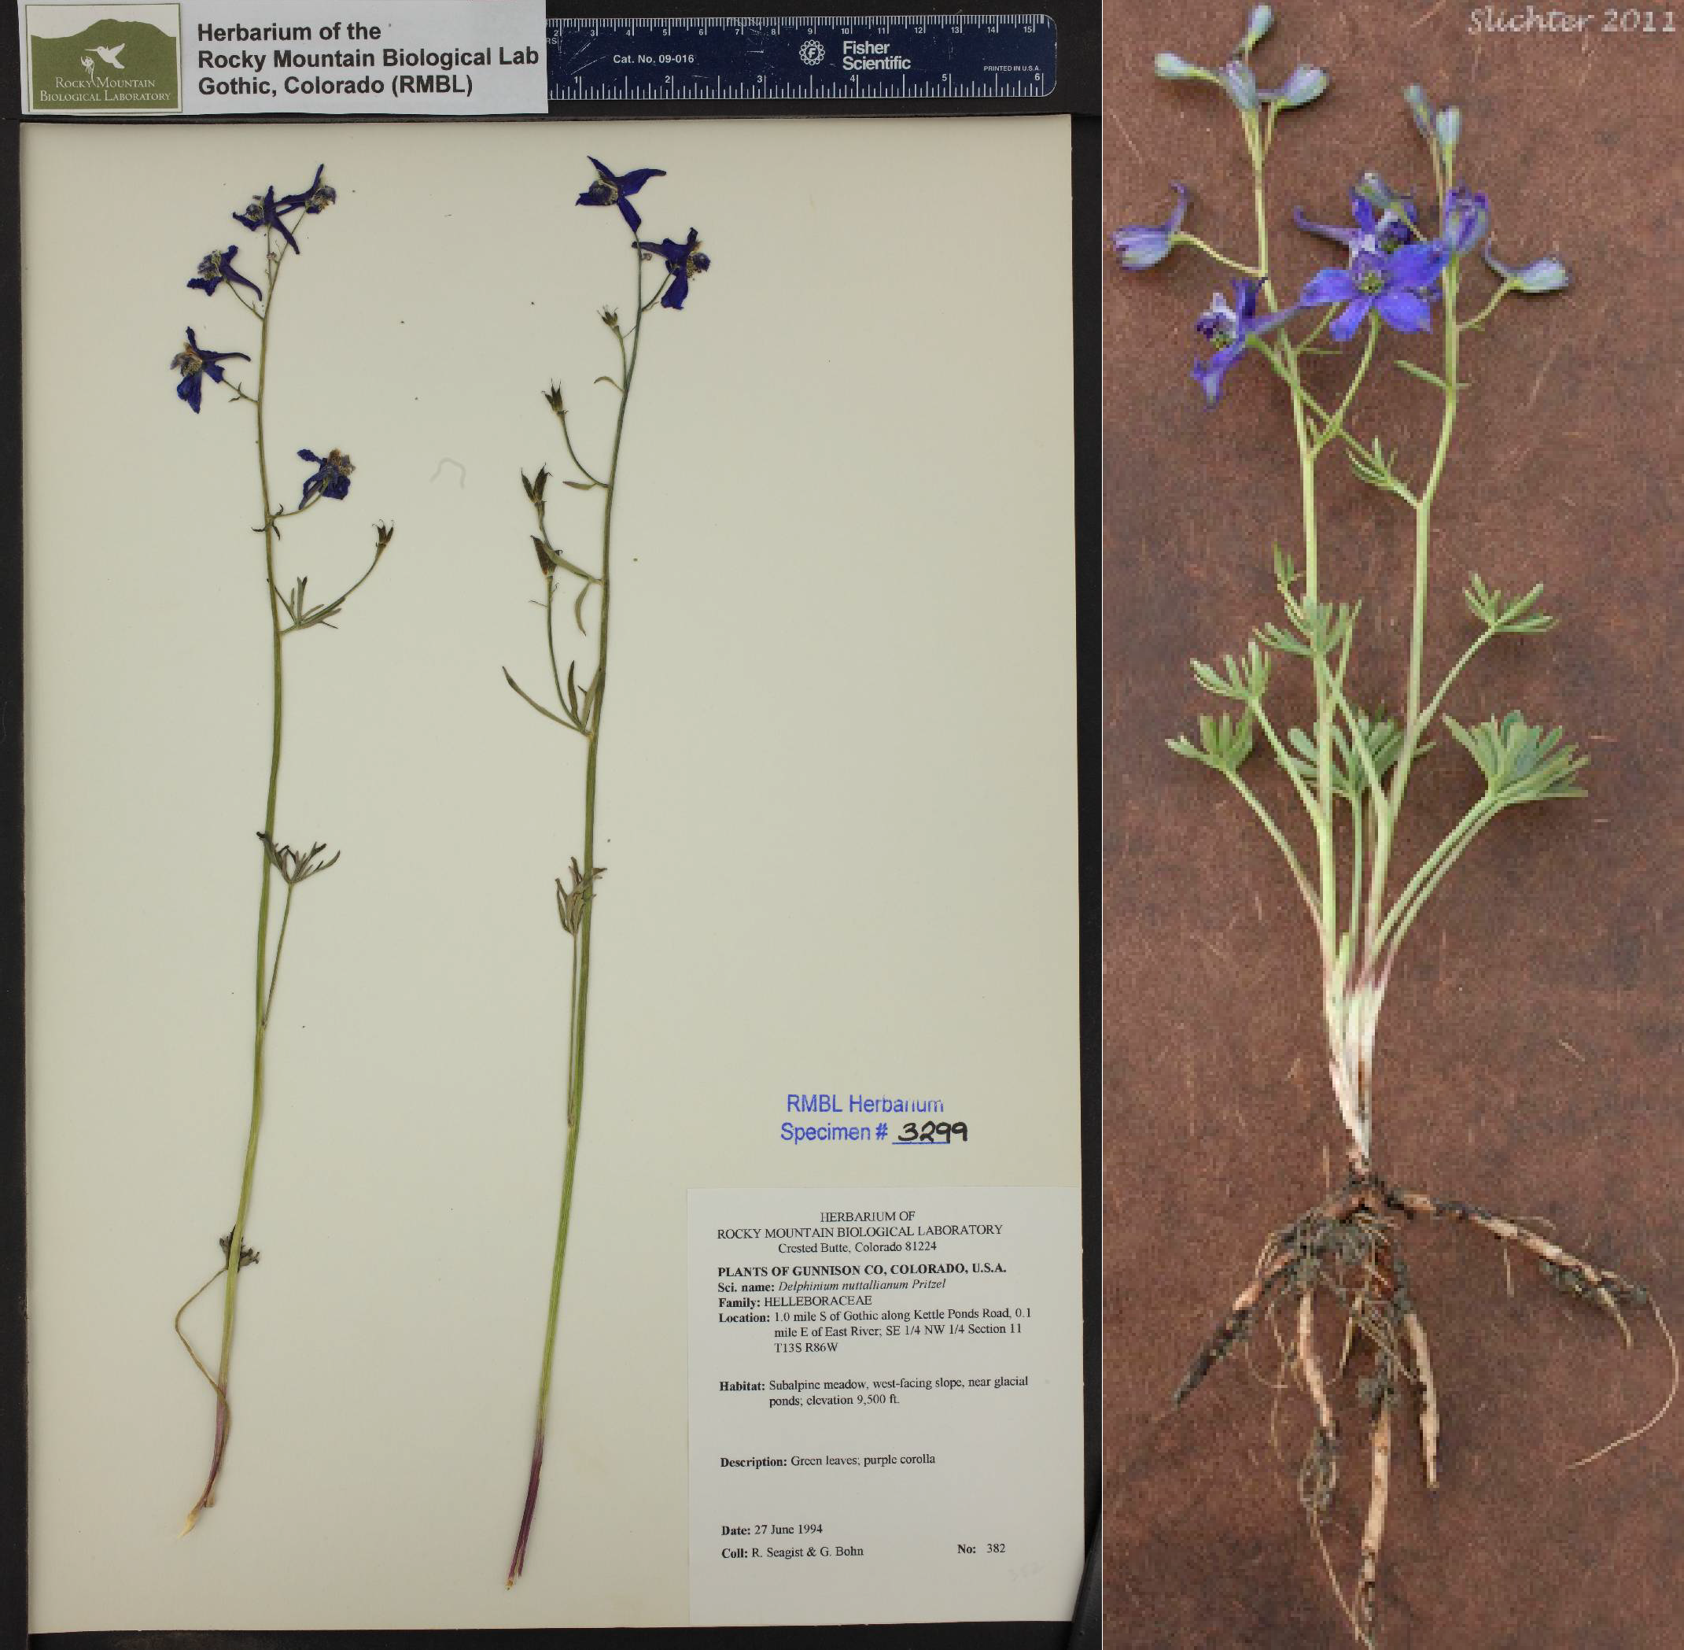

A)

B)

Length of largest basal leaf

Inflorescence height (cm)

Basal leaves

NOT basal leaves

Inflorescence height (cm)

**Figure 6.** Size measurements for *Delphinium nuttallianum.* A) Inflorescence height (cm) from the ground to the bottom of the uppermost flower and B) inflorescence height of the tallest inflorescence (two total) and length of the largest basal leaf (cm). Basal leaves are also shown in each A and B relative to leaves that are not basal.

*Measuring size of Lupinus bakeri* ( Figure ***7***):

* Total number of vegetative and reproductive stems
* Height of the tallest stem, just below inflorescence (cm)
* Length of the largest leaf on the plant (cm)

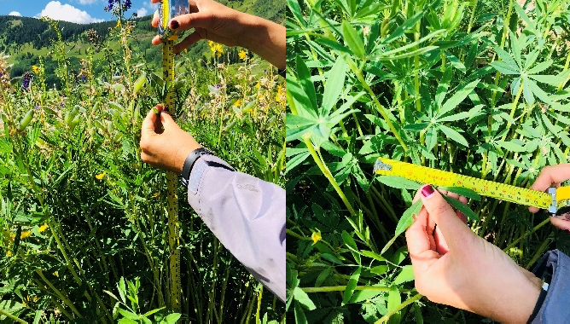

A)

B)

Length of largest leaflet

Stem height

**Figure 7.** Size measurements for *Lupinus bakeri*. A) Take the height of the tallest stem (usually reproductive). Do not measure the inflorescence, just measure the vegetative part of the stem (cm). B) Measure the length of the largest leaflet (cm).

*Measuring size of Erigeron speciosus* (Figure 8):

* Total number of vegetative and reproductive stems (or leaves for non- reproductive plants)
* Height of the tallest stem (cm)

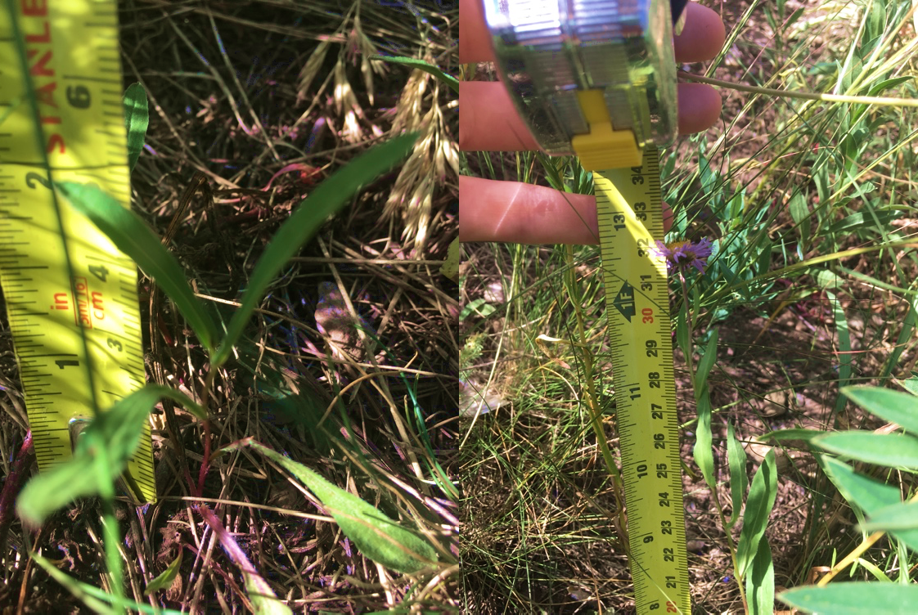

A)

B)

**Figure 8.** Size measurements for *Erigeron speciosus*. A) For non-reproductive plants, count the total number of leaves and take the height of the tallest leaf. B) For reproductive plants, count the number of stems and record the height of the tallest stem.

1. ***Record reproductive success***: When you measure plant size (except for

*Delphinium nuttallianum*), record the total number of flowers and fruits.

1. ***Record fly damage to flowers in Erigeron speciosus***: Once per season (typically before recording total reproductive success), determine the number of flowers with Tephritid fly damage **(**Error! Reference source not found.**).**

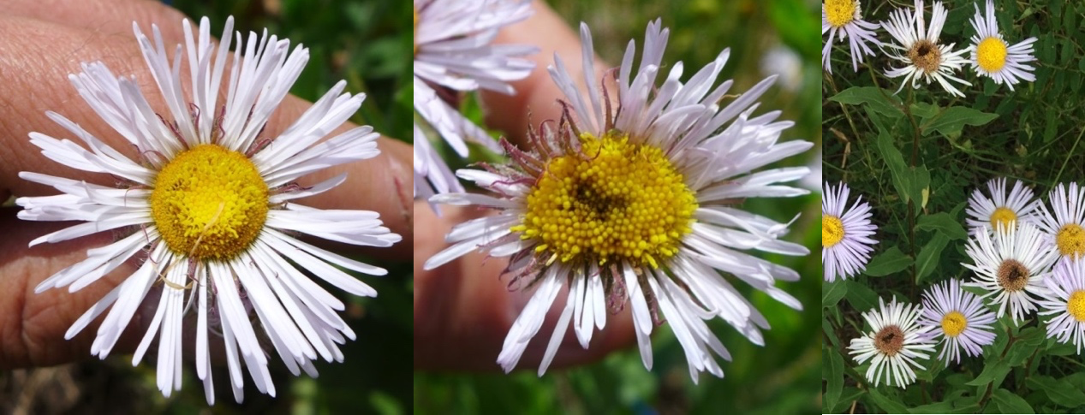

A) Undamaged

B) Damaged

C) Both

Figure 9. *Erigeron speciosus* A) undamaged, B) damaged, and C) undamaged and damaged flowers by Tephritid flies.

## *Recording phenology:*

1. Record flowering phenology on Monday, Wednesday, and Friday to match the long-term flowering phenology project. In 2019, due to time constraints, phenology was recorded 2x per week, on Tuesdays and Thursdays.
2. For each individual, record a mix of the following: total number of open flowers, total number of spent flowers, and total number of fruits. See below for details.
   1. *Recording phenology for Delphinium nuttallianum* (Figure 10):
      * Notes: This plant is the first of the three to flower in the season. Each reproductive plant will create 1 – 3 inflorescences, with multiple flowers on each.
      * Data: Record the number of open flowers, spent flowers, and fruits. Fruits form 1 – 3 follicles. We also recorded the total number of follicles on each fruit by inputting fruit number as the total number of follicles per fruit: p = 3 + 3 + 2 (three total fruits with 3, 3, and 2 follicles each).
      * Time commitment: Typically, one to two flowers are open at a time. During peak flowering season, daily phenology data collection will take approximately 1 to 2 hours.

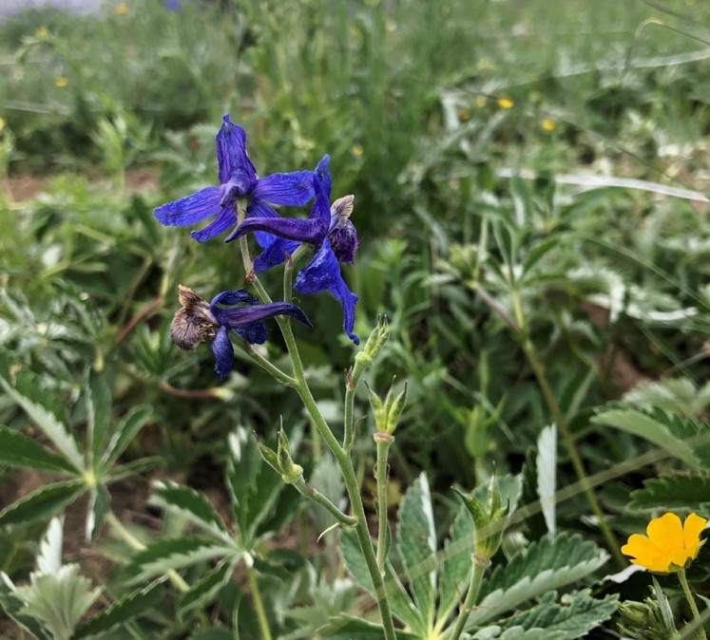

Spent flower

This fruit has 3 follicles

Fruits

Flowers

**Figure 10.** Flowers, spent flowers, and fruits on *Delphinium nuttallianum****.***

* 1. *Recording phenology for Lupinus bakeri* (Figure 11):

1. Notes: In a wet year, plants create up to 60+ inflorescences with 20 – 30 open flowers per inflorescence during peak flowering.
2. Data: Record the number of open flowers. Note: Fruits will sometimes start showing even when there is still a spent flower on the outside. To determine the difference between a spent flower and a fruit that is hidden, gently touch the flower and feel for a hardened fruit. *In 2019, number of spent flowers and fruits were counted more frequently. In future years only number of open flowers were counted.
3. Time commitment: During peak flowering season, daily phenology data collection will take approximately 3 – 4 hours.

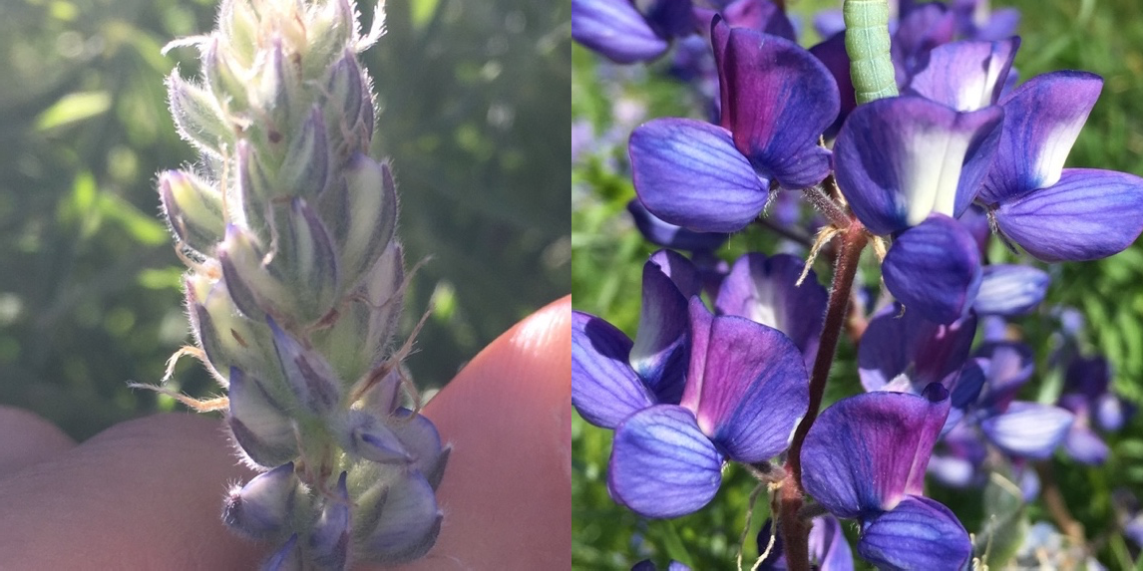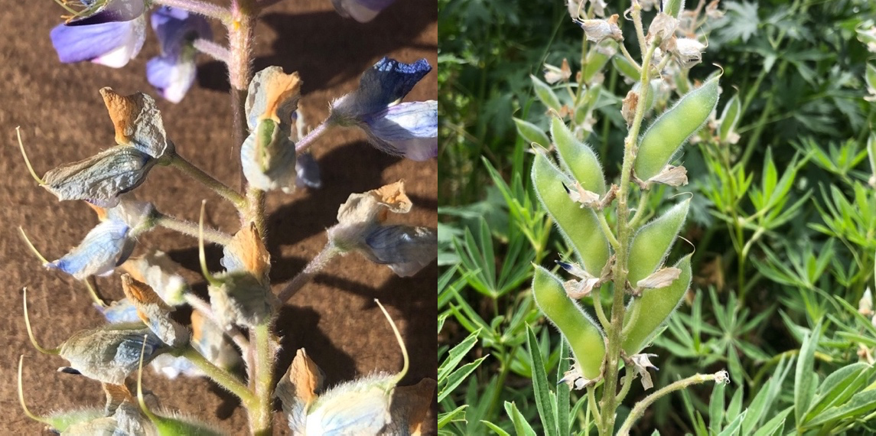

A) Buds

B) Flowers

C) Spent flowers + fruits

D) Fruits

**Figure 11.** A) Buds, B) flowers, C) spent flowers, and D) fruits of *Lupinus bakeri.*

* 1. *Recording phenology for Erigeron speciosus* (Figure 12):

1. Description: Each inflorescence will typically produce 1 – 3 flowers.
2. Data: Record the total number of open flowers on each plant. In 2019, spent flowers and fruits were also recorded.
3. Time commitment: During peak flowering season, daily phenology data collection will take approximately 2 – 3 hours.

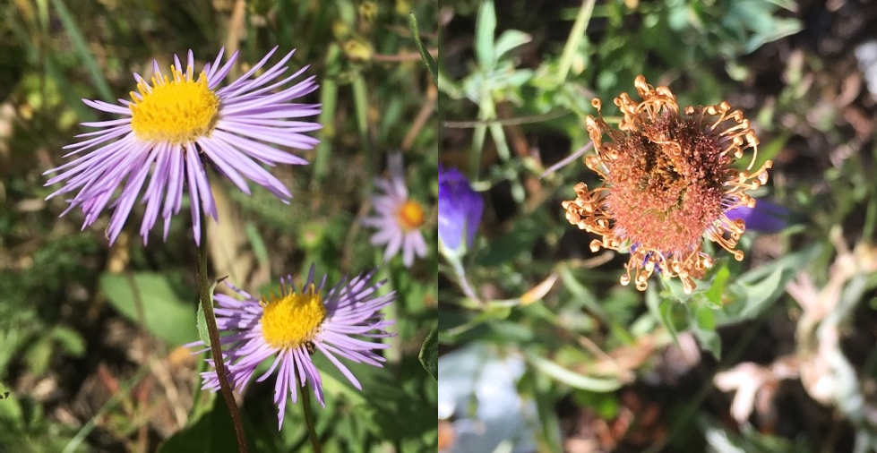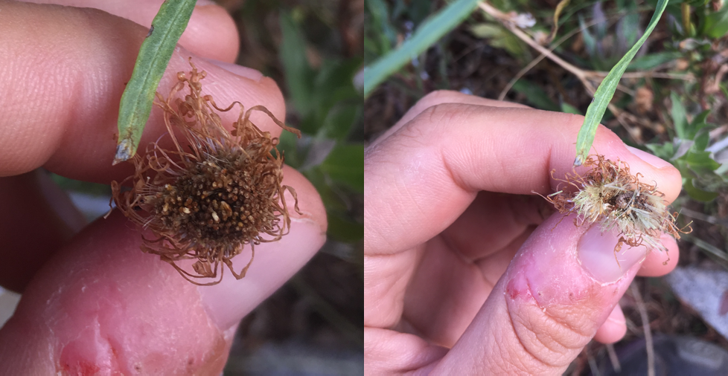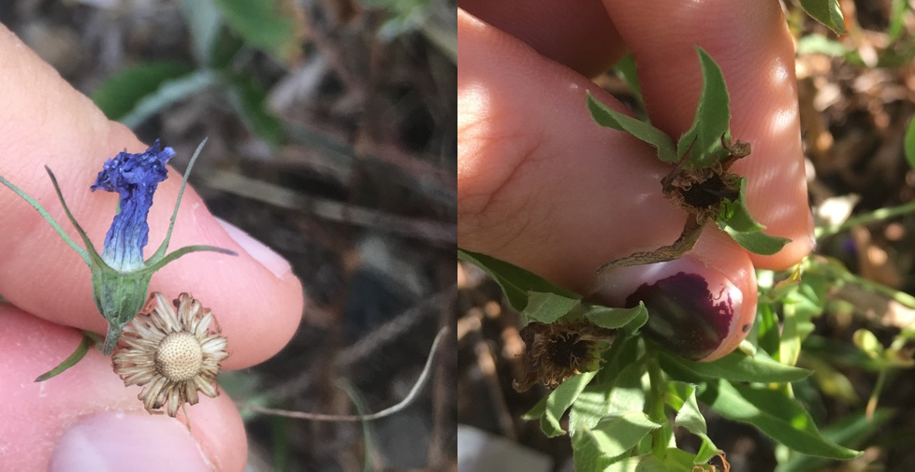

A) Flower

B) Spent flower

C) Spent flower

D) Fruit

E) Dispersed fruit

F) Aborted flower

**Figure 12.** *Erigeron speciosus* A) open flowers, B and C) spent flowers, D) fruit, E) dispersed fruit, and F) aborted flower.

# *How to record data*

## *Create a new data sheet*

For each species, create a new Microsoft Excel file with three tabs:

#### *Tab 1: demography*

1. Begin by opening the file from the previous year. The file for *Delphinium nuttallianum* will be titled “RPD_DENU_YYYY_Final.xlsx”
2. Copy the entire data sheet from the previous year, and remove the data from all columns EXCEPT:
   1. site
   2. species
   3. transect
   4. tag
   5. toothpick (if DENU)
   6. unique.id
   7. X
   8. Y
   9. notes

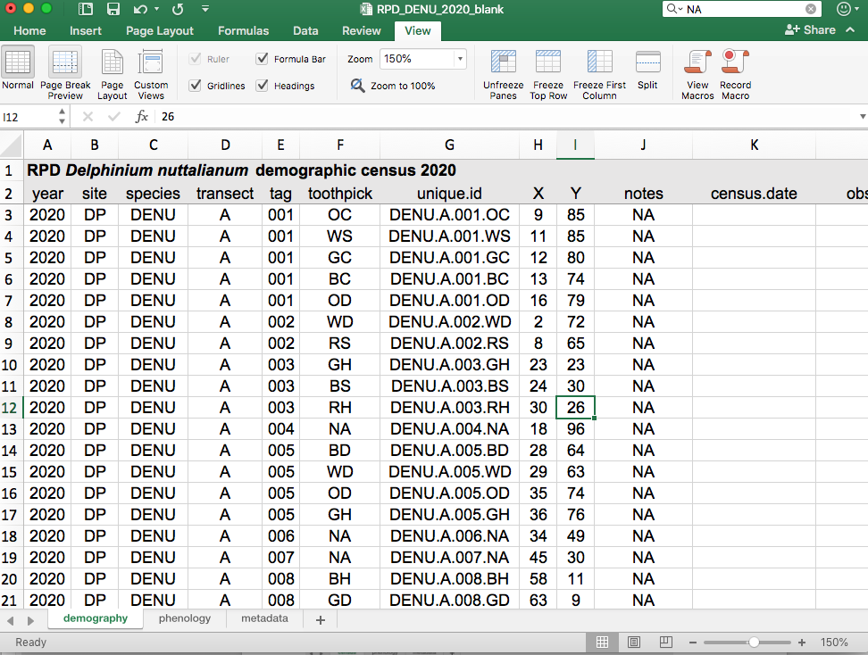

Three tabs, “demography”, “phenology”, and “metadata”

Data copied from 2019

Figure 13. Image capture of data sheet for 2020 for *Delphinium nuttallianum*. The data were copied from 2019. Notice three tabs at the bottom.

#### *Tab 2. phenology*

1. Copy the header from the previous year’s phenology census

#### *Tab 3. metadata*

1. Copy the metadata from the previous year and make updates to reflect any changes in the data (i.e., new columns, new transects, removed columns from previous years, etc).
2. Save the file as “RPD_DENU_YYYY+1_blank.xlsx”

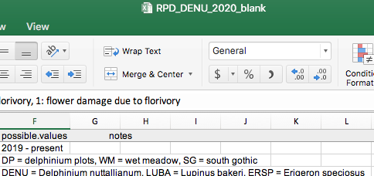

## *Data input*

1. Every time you collect new data in the field, make sure you save the file with the date at the end. This process helps with version control and finding mistakes.
   1. For example, after you collected phenology data on 20 May 2020, the file should be renamed “**RPD_DENU_2020_05.20.2020.xlsx.”**
   2. Make sure to back up the file every day, as iPads and digital notebooks sometimes break in the field and data can be lost.

# *Maps of transects*

*\*To recreate these maps, you can use the code available in OSF\**

Demography_Plot_Maps.R

*Lupinus bakeri* (2019)

200

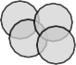

**Transect A**

21

43

148

113 150

1214

15

180

9

27

26

28

29

20

56147

1417154467

22 24325

21

34

16187

19

30 32

31 33

150

100

50

0

200



**Transect B**

36

38

37

43

46

61

57

56

62

49

44

47 52

64

63

45

51

50

58

59

40

4411

39 42

55

53 54

60

65

150

100

50

Y coordinate (cm)

0

200



**Transect C**

83

68

8810

71

70

737756

79

74

82

66

78

84

77

150

100

50

0

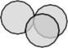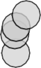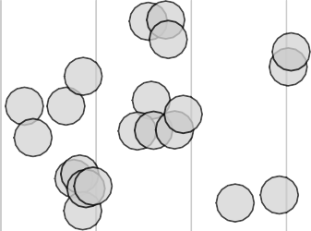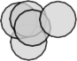

**Transect D**

112245

113

110034

133

|  |  |  |  |  |  |  |  |  |  |  |  |  |  |  |
| --- | --- | --- | --- | --- | --- | --- | --- | --- | --- | --- | --- | --- | --- | --- |
| 200  150  100  50 |  | 85 | 87  88 | 91 | 96  95 | 97  151 | 152  98  19090 | 101506  107  108  101911011 |  | 115  114 | 122 | 123  126  127  14392  131  128  130 | 136 | 11313849142  137 |
| 0 |  |  |  |  | 93 |  | 101 |  | 117 | 116 |  | 129 |  |  |

0 100 200 300 400 500 600 700 800 900 1000

X coordinate (cm)

*Lupinus bakeri* (2020)

200

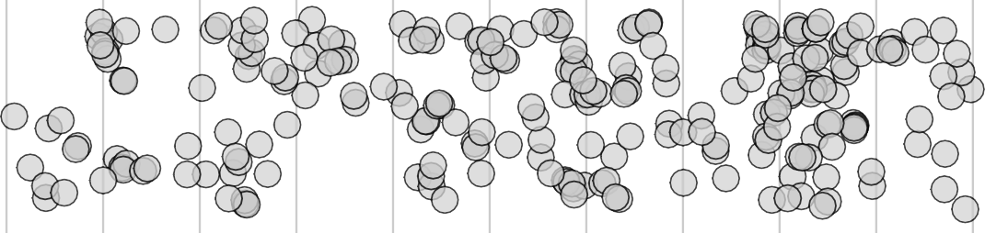

**Transect A**

|  |
| --- |
|  |
| 4 148 221166 14 15 244252 263 261 282328833 28225**86** 32318171 303331177 327  23 217 12 150 277 283 285 **303** 321 341 347  2113 1113 23232934 242852347 226265850 291 28292 331261 334  2102 180 236 227755 271 292298 331008 322333332333555 343 339  211 9 224242411 273275 **2**2**6**6**8**8 27 295 318 309 |
| 209 232028 223 267 226688 26 29 301 330055 342336  209 215 228 237 304 302 294 314 306 333  225 24338 235 259 2722227282882822330022 28 313313333311113222233807 345  250 2555 279 82 328  201 270 296 332200 346 |
| 202005 231 20 257 23 326 333377**3**33**3**33**0**00  226 20 249 2425299  220076 227 220 245 264 266 274 22 293 332255 331 329  5 233 258 21 8 300 3343444 340 34  7 222 19 |
| 202 1645114477 224214 146 219 1618 246 260 281 30 32 319  204348 208 17 2225562654226699 284 315 323  251  203 229218 240 262 227766 29729731 29303  324 |
|  |

150

100

50

0



**Transect B**

38

43

46

61

36

37

57

62

49

47

56

44

52

63

45

51

50

58

59

40

41

39

55

153

53 65

60

200

150

100

50

Y coordinate (cm)

0

200

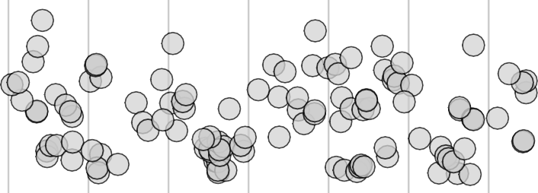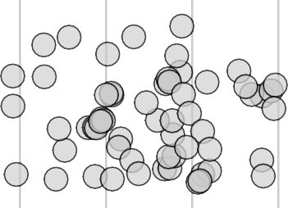

**Transect C**

|  |
| --- |
|  |
| 407 442 525  499 526  406 418 463 487 498 501 538 |
| 405 417 434 4414452456 475 83 533  416 419 435 454 4646723 490 491 495 555111012 530 534 532  440044 408 440 47480 8810 55005**4** 519 525925831  68 76 436447 458 79 493 521 |
| 403 71 420 7375 4798 483 486 523 535  **402** 47105 74 443 4464621 464746689 484 482 852**50023** 520522  421424 457 439 **485** 494 5 500 518 524  422 423  434030 433 445 78 507 541 542 |
| 404101410 44224472299432 460 465 477 448889 492 509 551176 84  46060 414411 42747298 431 459 447701 551145 537  409 442255 476 481 513 536  412 413 424626 44444484455135 496 497506 553490 527  412 77 50 464434738 |
|  |

150

100

50

0

200

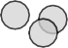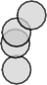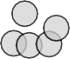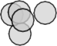

85

87

88

**Transect D**

105106

107

115

152 114

121324

122

126

127

125

97

98

108

1

96

151

113

109110111

32

131839 142

131

91

94

95

141

137

99

100

128

136

133

93

110034

116

101

117

130

129

150

100

50

0

0 100 200 300 400 500 600 700 800 900 1000

X coordinate (cm)

Y coordinate (cm)

*Lupinus bakeri* (2021)

200

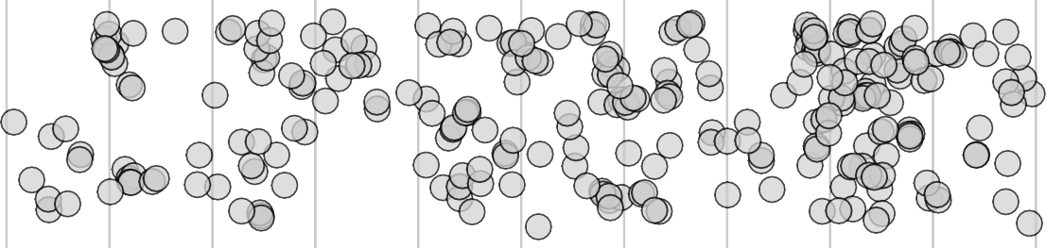

**Transect A**

4

148

221133

2 1

3 217

2102

216 12

11

216

14

13

15

244

150

252

263

283228833

28585

2 228866

311

303 317

327

211

180

232 234

236 242242141

223

239

248252347

261

226652580

277

283

2833711 33003**3** 317

268190

341 347

291

31261

3321

334

273 275

272575

60**2**6**68**

271

282299922

318

292298 308

3

30910608 614

322 33323335355 343 339

9 230

228

268268

268

220099

267

304

27

26

295

294

29

607

301 305

613

314 306

305

612

342

336

215

225

237

243 235

238

272 227882228822 330022

28

250 222555595

272882

302

313313 333311112223238

313 307

611 333

345

201

205

200

220076

601

231

20 257

20

279

270

296

323020

328

346

226600

227

220

249

245

22

23

24 25 299

264

5

233

604

202

1465 147

67 147

222

19

603

266

258

260

274

21

288

293

326

332255

300

333377 333333000

331

340

334443444

660096909

329

34

224 214

219

204

203

208

348

16 18 602 246

17

240

252656254 226699

281

30

32

319

251

284

313519

315

323

229 218

262

218

227766

29729731 33

605

290

324

150

100

50

0

200

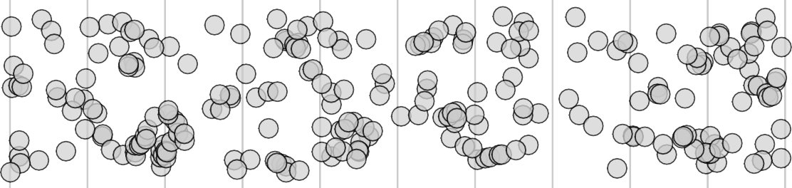

**Transect B**

734

717

735

861

736

694695

669978

747

680

750

792

749748

759

762 864

690

38 779 43

689 668822

668811682

830751

46

767363761

763760

780

696

683 752

865 783

785786

782

875784

57

789

835

856

874853

2

834

834 836

781

61

863

87876

791

62

833 858 838

859 820 857

36

770

787887

37

862

837 4 872

83881225

860

867

756

757

767876699

691

688 746486

718 774410

738

6845

827797

841842

758

732

44

828

731

728

772

771

773

819

49

47

832

56

839

866

52

798

794

870

887713

884403

808

63

801

848751

849

790 822

822

823826

800

795

67878

742 774 707107202 51

707202

796

58

765

708

729 82495

771111 726

720

764

733

793 776 799

778721

712

700

699

848448

50

59

806802

845

802805

818 810812

881187

709

739

737 775753545 41

713

727

55

804

814 811 816

815

153

710 706

743746

745

47066

47717755

716 725 714

855

767

692 693 772273321

715

730

53707304

770055

803 881813133

846 65

719

39

707

721

724

807809

854

722

60

150

100

50

0

200

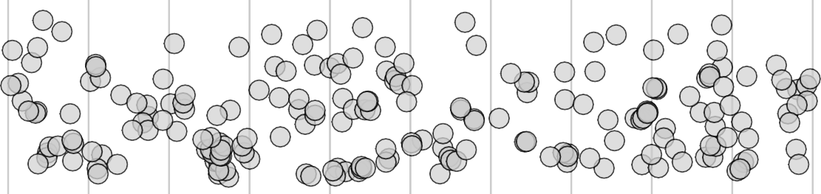

407

652

665

442

**Transect C**

653

667

525

499

526

671 406

405

418

664

650

463

487

498

501

538

417

417

416

456

434 441 452

475

435

449

454

466

83

490

491

495

404

404

408

419

4732

510

551112

530

474

533

534 532

480

8810

79

55500054

531

403

6744002

68

76

440

519

529528

42071 73 75

415

74

436 447

446 462

458

4798

483

493

521

658

421 424

668 422

70

443

666

461

457

467464869

439

486

484

523

**485** 482

494

550033

85250022

520522

524

656535

655

657

423

410

434030 433

445

404101

429 432

42472

4274742299 431

78

460 663

459

662

465 477

448889

492

500

507

518

541 542

515716

669 412 413

400 409

66 414

411

4428

44

660

654

509

84

2255

428

447701

661 660 659

515415

537

412

47274626

444 4451535 459

476

481

497 506 513

536

5

527

426

434738 651448450

496

651

464

53490

150

100

50

0

200

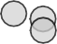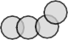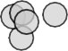

**Transect D**

105 106

85 87

88

107

115

114

123

124

125

126

152

122

127

97

98

108

149

132

151

113

109110 111

96

131

131839 142

141

137

95

94

128

136

91

99

100

101304

130

133

93

116154

117

101

129

150

100

50

0

0 100 200 300 400 500 600 700 800 900 1000

X coordinate (cm)

*Delphinium nuttallianum* (2019): numbers are too difficult to see and therefore omitted

100

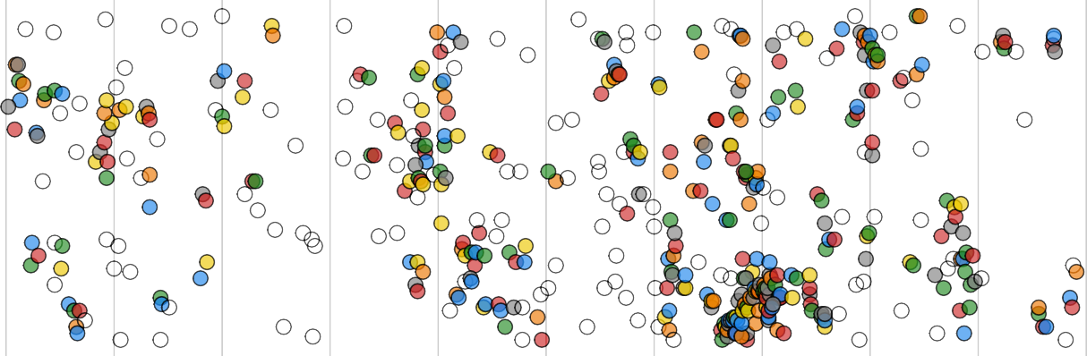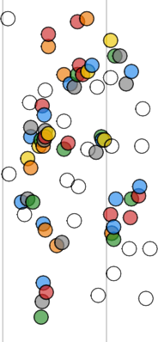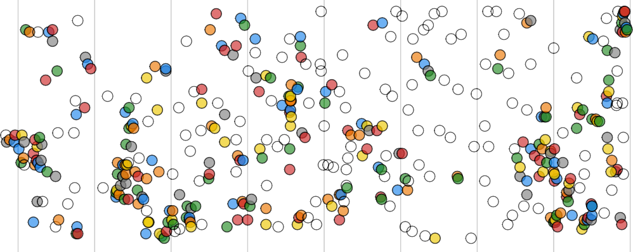

**Transect A**

**Transect B**

75

50

25

0

Y coordinate (cm)

100

75

50

25

0

0 100 200 300 400 500 600 700 800 900 1000

X coordinate (cm)

Toothpick color

blue green

orange red

white  NA yellow

100

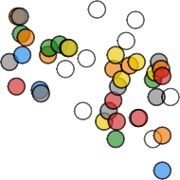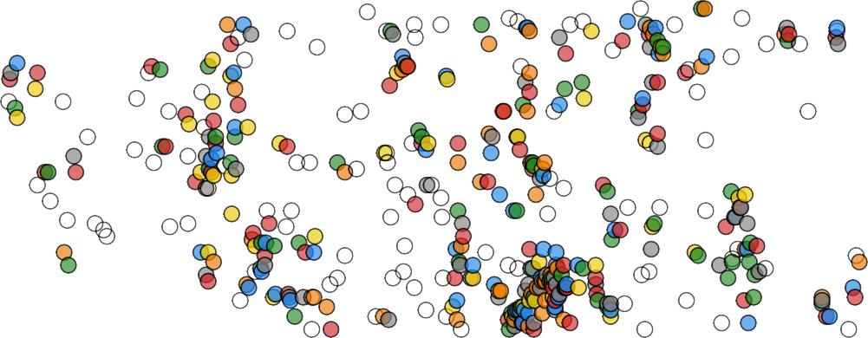

**Transect A**

75

50

25

0

Y coordinate (cm)

100

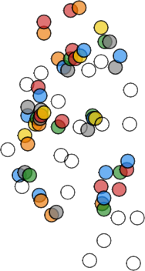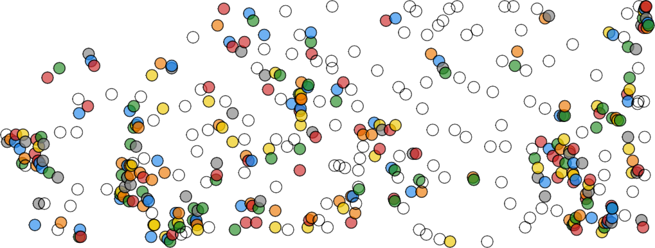

**Transect B**

75

50

25

0

0 100 200 300 400 500 600 700 800 900 1000

X coordinate (cm)

Toothpick color

blue green

orange red

white  NA yellow

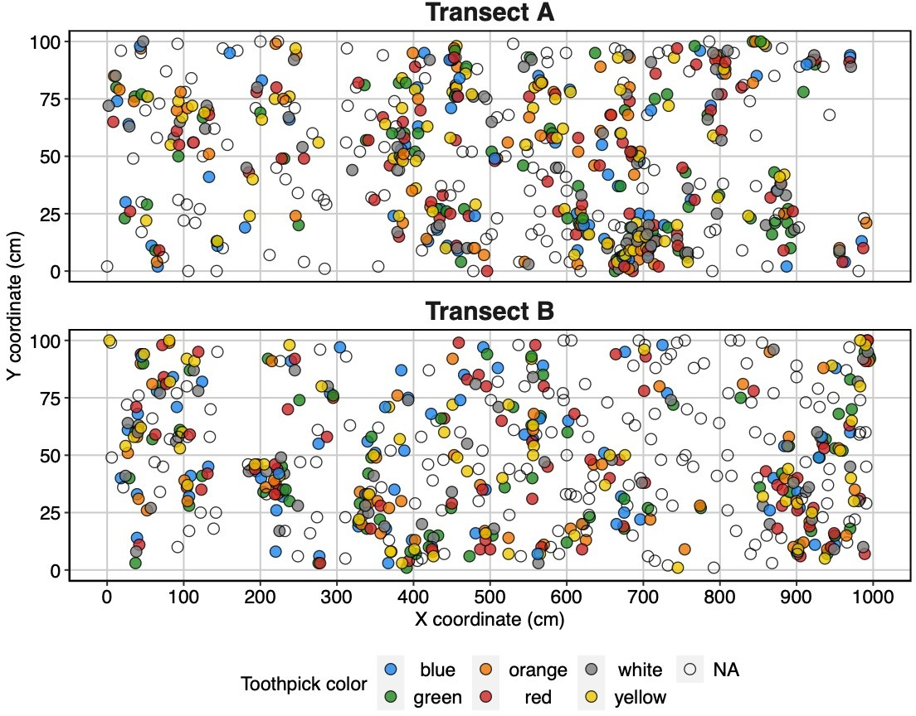

*Erigeron speciosus* (2019)

100

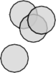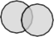

**Transect A**

157

99

26

43

42

49

63

97

2 5

1011

76

7780

3

25

46

59

85

19080

101

1

41

44

156

79

48

12

27 34

155

9

3389

40

65

72

73 83

18

21

28

57

56

32 35

61

70

14

37

91

15 20

51

15343

66

84

90

62

71

8

1316

24

29

36

75

50

25

0

Y coordinate (cm)

100



**Transect B**

162

152 153

107

113

114

120

121

116

161

163

136

101608

135

146

126

148

101405

109

158

110

131

150

117

133

147 129

151

149

102103

112

111

118

159

132

145

122

160

75

50

25

0

0 100 200 300 400 500 600 700 800 900 1000

X coordinate (cm)

RMBL Phenology Demography Metadata RPD_Metadata_2021.docx

*Erigeron speciosus* Transect A and B (2020)

100

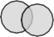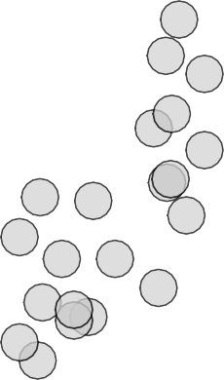

**Transect A**

155

99

26

2

1011

43

42

3

25

46

171

49

59

156

63

7780

97

19080

171A

85

79

76

101

172

1

44

41

165

4 7

48

166

12 27 34

5 6

9

3389

40

65

72

73 83

18

21

28

157

164

32 35

57

56

61

70

37 91

15 20

1316

14 167

169

17303

51

66

154

84

62

71

90

8

168

24 29

36

75

50

25

0

Y coordinate (cm)

100

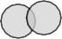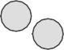

**Transect B**

152

107

113

114

153

120 121

162

108

106

116

136

141673

135 148

105 110

104

126

131

150

117

133

158 109

174

102103

112

111

118

129

159 132

160

122

147

145

151

149

75

50

25

0

0 100 200 300 400 500 600 700 800 900 1000

X coordinate (cm)

*Erigeron speciosus* LUBA Transects (2020)

200

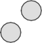

**Transect LUBA A**

E4

E7

E58

E18

E1

E63

E71

E17

E69

E22

E82 E9

E6

E11

E15

E19

E20

E14

E75

E68

E81

E13

E3

E16

E21

E5 E2

E23

E8

E10

E12

E59

E73

E72

E60

E64

**Transect LUBA C**

E29

E25

E31

E30

E27

E28

E70

E24

E32

E26

E83

**Transect LUBA D**

E8E079

E47

E48

E36

E41

E67

E42

E55

E35

E81

E37

E40

E45

E78

E49

E34

E66

E54

E56

E65

E43

E77

E46

E52

E53

E62

E39

E38

E57

E33

E44

E61

E74

E51

E50

E76

150

100

50

0

200

Y coordinate (cm)

150

100

50

0

200

150

100

50

0

0 100 200 300 400 500 600 700 800 900 1000

X coordinate (cm)

39

*Erigeron speciosus* Transect A and B (2021)

100

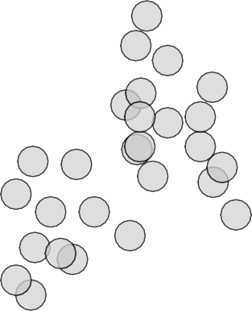

**Transect A**

155

99

26

1011

43

42

171

49

63

157

7780

97

171A

76

25

46

85

98

101

44

41

156

17579

165

4 7

177 48 178

166

27 34

5 6

9

3389

40

178

57

56

65

72

73 83

18

21

28

32 35

61

70

164

14

37

91

15 20

169

17303

51

66

71

84

90

8

1316

24

168

29

62

36

75

50

25

0

Y coordinate (cm)

100

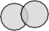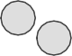

**Transect B**

176

152

107

113

114

153

120 121

162

108

106

116

136

141673

135 148

105 110

104

126

131

150

133

158 109

174

117

179

102103

112

111

118

129

159

160

132

147

151

149

122

145

75

50

25

0

0 100 200 300 400 500 600 700 800 900 1000

X coordinate (cm)

40

*Erigeron speciosus* LUBA Transects (2021)

200



**Transect LUBA A**

E102 E4

E7

E58

E18

E3 E1

E63

E11a

E101 E71

E17

E69

E22

E82 E9

E11

E15

E19

E6

E100

E20

E14

E75

E6E8a68

E81

E5

E13

E16

E2

E21

E2E3103

E8

E10

E73

E72

E12

E59

E60

E64

**Transect LUBA C**

E29

E25

E31

E30

E27

E28

E70

E24

E32

E26

E83

**Transect LUBA D**

E8E079

E47

E48

E36

E41

E67

E42

E55

E35

E81

E40

E45

E78

E49

E37

E34

E66

E54

E56

E65

104

E43

E77

E46

E52

E53

E62

E39

E38

E57

E33

E44

E61

E74

E51

E50

E76

150

100

50

0

200

Y coordinate (cm)

150

100

50

0

200

150

100

50

0

0 100 200 300 400 500 600 700 800 900 1000

X coordinate (cm)

# *Metadata*

## *Demography metadata:*

Column heading: year

Description: Year when census conducted

Date type: numeric

Measurement unit: YYYY

Possible values: 2019 – Present

Column heading: site

Description: Two letter abbreviation of the field site where transects are

located. At this time, each species is located in a different “site.” We added this column in 2019 in case additional transects are added elsewhere in the future.

Data type: Character

Measurement unit: NA

Possible values: “DP”: David’s Delphinium plots in Gothic Townsite

“SG”: South Gothic “WM”: Wet Meadow

Column heading: species

Description: Four letter abbreviation for each species

Data type: Character

Measurement unit: NA

Possible values: “DENU”: *Delphinium nuttallianum*

“LUBA”: *Lupinus bakeri*

“ERSP”: *Erigeron speciosus*

Column heading: transect

Description: Letter code identifying each demographic transect (see GPS

coordinates for exact location earlier in this metadata file)

Data type: Character

Measurement unit: NA

Possible values: “A” or “B” for DENU

“A” or “B” or “C” or “D” for LUBA

“A” or “B” or “LUBA A” or “LUBA C” or “LUBA D”

Column heading: tag

Description: Each plant (or group of plants) for each species are labeled numerically with an aluminum tag.

Data type: Numeric

Measurement unit: NA

Possible values: 1 – 877 (in 2021)

Column heading: toothpick

Description: *Delphinium nuttallianum* and *Lupinus bakeri* seedlings are

often close together, so use one aluminum tag for a group of plants and seedlings and used colored cocktail toothpicks to identify individual plants within a group.

Data type: Character

Measurement unit: NA

Possible values: Each cocktail toothpick is a different color and shape. Each

code consists of the color code and the shape code (example: Blue Heart = BH, White Diamond = WD)

Color codes for toothpicks:

1. Red = “R”
2. Orange = “O”
3. Yellow = “Y”
4. Green = “G”
5. Blue = “B”
6. White = “W”

Shape codes for toothpicks:

1. Hearts = “H”
2. Clubs = “C”
3. Diamonds = “D”
4. Spades = “S”
5. Other = “B”

Column heading: unique.id

Description: Unique plant ID for the demography project. Concatenation

of species, transect, tag, and toothpick (if applicable).

Data type: Character

Measurement unit: NA

Example: DENU.A.120.RH: *D. nuttallianum*, transect A, tag 120 with a red heart toothpick

LUBA.C.081: *L. bakeri,* transect C, tag 081

Column heading: X

Description: X coordinate: the X (position along the tape in cm, east to west) coordinates of the plant

Data type: Numeric

Measurement unit: cm along the transect tape Possible values: 0 – 10000

Column heading: Y

Description: Y coordinate: the Y (distance from the bottom of the tape,

north to south) coordinates of the plant

Data type: Numeric

Measurement unit: cm along the transect tape

Possible values: 0 – 100 for DENU and ERSP A and B

0 – 200 for LUBA and ERSP in LUBA A-D plots

Column heading: notes

Description: Short notes referring to permanent features of the plant or if

a tag was placed in a different location (for example “tag is 10cm below and to the 10cm left of the plant”)

Data type: Character

Measurement unit: NA

Column heading: census.date

Description: Date when demographic census occurs

Data type: Date (US)

Measurement unit: MM/DD/YYYY

Possible values: 07/09/2019 – present

Column heading: observer

Description: Initials of researchers conducting the census

Data type: Character

Measurement unit: NA

Possible values: 2019 - RD: Rebecca Dalton, AT: Alyssa Turner, AW: Ashely Woolman, RDi: Rachel Dickson

2020 - NU: Nora Underwood, BI: Brian Inouye, RH: Rebecca Hayes, FA: Fatima Alcantara, HS: Hannah Stouter, DM: David McNutt,

2021 - NU: Nora Underwood, BI: Brian Inouye, RH: Rebecca Hayes, RP: Rebecca Prather, RG: Rhyne Gulley, DM: David McNutt, SP: Sahalie Pittman

Column heading: surv

Description: Survival from previous year (1 or 0).

Data type: Numeric

Measurement unit: NA

Possible values: 0: Plant did not survive 1: Plant survived

Column heading: seedling

Description: Whether or not the plant is a newly tagged seedling (1, 0, or

NA). Each year, we tag new individuals. Sometimes these individuals are very large and were just missed in the year before (or perhaps were dormant) and therefore they receive a 0. If the plant is newly tagged and small enough to be a seedling, use a 1.

Data type: Numeric

Measurement unit: NA

Possible values: 0: if newly tagged plant is large and was missed or dormant

in the previous year or plant tagged in previous year 1: if plant is newly tagged and is small enough to be a seedling

NA: plant is missing

Notes: These data can be used when quantifying recruitment.

Column heading: browsed

Description: Whether or not the plant was eaten by an animal, most likely

deer (0 if not eaten, 0.5 if half eaten, 1 if fully eaten)

Data type: Numeric

Measurement unit: NA

Possible values: 0: No indication of browsing

1: part of plant removed due to browsing

Notes: This information is useful because sometimes size measurements are missing, or total reproductive success is lower than daily phenology counts because browsing occurred after phenology but before the demographic census

Column heading: comments

Description: Temporary features of the plant that apply to only a single

year’s census. Example: “Plant completely eaten by a small mammal, could not get plant size"

Data type: Character

Measurement unit: NA

*Size column names:*

*\**These columns will be used to calculate plant size.*

*See *“*Equations relating plant size to biomass*”* for more information.*

Column heading: basal.leaf.no (DENU only) Description: The number of basal leaves

Data type: Numeric

Measurement unit: Number of basal leaves

Notes: Did not collect in 2019 because we waited too long to conduct demographic census. Collected in 2020 – 2021.

Column heading: basal.leaf.length (DENU only) Description: The length of the largest basal leaf

Data type: Numeric

Measurement unit: mm

Column heading: infl.no (DENU only)

Description: The total number of inflorescences on the plant

Data type: Numeric

Measurement unit: Number of inflorescences

Column heading: inf.height (DENU only)

Description: The height of the tallest inflorescence, from the ground to

just below the bottom of the uppermost flower.

Data type: Numeric

Measurement unit: mm

Column heading: no.of.true.leaves (LUBA)

Description: The number of true leaves on a seedling or non-reproductive

plant.

Data type: Numeric Measurement unit: Number of true leaves

Column heading: stem.no (LUBA + ERSP)

Description: The number of inflorescences and vegetative stems. For

non-reproductive plants with no visible meristem and leaves emerging from the soil (including seedlings) stem number is the number of distinct leaf clusters.

Data type: Numeric Measurement unit: Number of stems

Column heading: stem.height (LUBA + ERSP)

Description: For non-reproductive plants with visible meristems (no stems

w/ flowers, buds, or aborted buds) stem height is the distance from the ground to the apical meristem. For non- reproductive plants with no visible meristem and leaves emerging from the soil (including seedlings) stem height is the length of the longest petiole. For plants with at least one reproductive stem (i.e., inflorescence, even if aborted) stem height is the distance from the ground to the bottom of the inflorescence.

Data type: Numeric

Measurement unit: cm

Column heading: leaf.length (LUBA only)

Description: The length of the largest leaf on the tallest vegetative stem Data type: Numeric

Measurement unit: cm

*Reproduction column names:*

Column heading: inf (DENU)

Description: Inflorescence present (1 or 0). This column is useful for

identifying which plants to include in the phenology census.

Data type: Numeric

Measurement unit: NA

Possible values: 0: Inflorescence not present, 1: Inflorescence present, NA:

plant did not survive previous year or is dormant

Column heading: inf.tot (LUBA)

Description: Total number of stems containing inflorescences (flowers, viable buds, or aborted buds).

Data type: Numeric

Measurement unit: NA

Column heading: inf.actual (LUBA)

Description: Total number of stems containing viable inflorescences

(flowers or viable buds). This value does NOT include aborted buds.

Data type: Numeric

Measurement unit: NA

Possible values: 0 – 52 (2021)

Column heading: flower.no (DENU, LUBA, ERSP)

Description: The total number of flowers produced over the season Data type: Numeric

Measurement unit: Number of stems

Notes: NA if plant was non-reproductive

Column heading: fruit.no (DENU, LUBA, ERSP)

Description: The total number of fruits produced over the season Data type: Numeric

Measurement unit: Number of stems

Notes: NA if plant was non-reproductive

Column heading: follicle.no (DENU only)

Description: Each fruit produces up to three follicles. We recorded the

total number of follicles per fruit by inputting a formula, where each value is the number of follicles per fruit

Data type: Numeric Measurement unit: Number of follicles

Notes: NA if plant was non-reproductive

Example formula: = 3 + 2 + 1 + 3

This plant has four fruits, one with a single follicle, one with two follicles, and two fruits with three follicles

Column heading: aborted (DENU only)

Description: The total number of aborted buds on the plant.

Data type: Numeric

Measurement unit: Number of aborted buds

Notes: NA if plant was non-reproductive

Column heading: flower.aborted (ERSP only)

Description: The total number of aborted flowers on the plant.

Data type: Numeric

Measurement unit: Number of aborted flowers Notes: NA if plant was non-reproductive

Column heading: flower.damaged (ERSP only)

Description: The total number of flowers on the plant damaged by

Tephritid flies

Data type: Numeric

Measurement unit: Number of damaged flowers Notes: NA if plant was non-reproductive

## *Phenology metadata:*

Column heading: date

Description: Date when phenology census occurs

Data type: Date (US)

Measurement unit: MM/DD/YYYY

Possible values: 06/28/2019 – present

Column heading: observer

Description: Initials of researchers observing phenology

Data type: Character

Measurement unit: NA

Possible values: 2019 - RD: Rebecca Dalton, AT: Alyssa Turner, AW: Ashely Woolman, RDi: Rachel Dickson

2020 - NU: Nora Underwood, BI: Brian Inouye, RH: Rebecca Hayes, FA: Fatima Alcantara, HS: Hannah Stouter, DM: David McNutt,

2021 - NU: Nora Underwood, BI: Brian Inouye, RH: Rebecca Hayes, RP: Rebecca Prather, RG: Rhyne Gulley, DM: David McNutt, SP: Sahalie Pittman

Column heading: unique.id (copied from demographic data)

Description: Unique plant ID for the demography project. Concatenation

of species, transect, tag, and toothpick (if applicable).

Data type: Character

Measurement unit: NA

Example: DENU.A.120.RH: *D. nuttallianum*, transect A, tag 120 with a red heart toothpick

LUBA.C.081: *L. bakeri,* transect C, tag 081

Column heading: buds

Description: Total number of unopened flower buds on the day of the

phenology census

Data type: Numeric Measurement unit: number of flower buds Possible values: 0 – 9 or NA

Notes: We only scored unopened flower buds for DENU in 2019

Column heading: flower.open

Description: Total number of opened flowers on the day of the phenology

census

Data type: Numeric

Measurement unit: number of open flowers Possible values: 0 – 3342 or NA

Notes: For LUBA and ERSP, we entered these data using the formula “= flowers per stem 1 + flowers on stem 2… flowers on stem n”

Example: “= 4 + 5 + 3 + 2 + 1” is equivalent to 15 open flowers

Column heading: flower.spent

Description: Total number of spent flowers on the day of the phenology

census

Data type: Numeric

Measurement unit: number of spent flowers Possible values: 0 – 1799 or NA

Notes: We were unable to do this for the whole season for LUBA in 2019, and only have partial data for this column

For LUBA and ERSP, we entered these data using the formula “= flowers on inflorescence 1 + flowers on inflorescence 2… flowers on inflorescence *n*”

Example: “= 4 + 5 + 3 + 2 + 1” is equivalent to 15 open flowers

Column heading: fruit.no

Description: Total number of immature and mature fruits

Data type: Numeric Measurement unit: number of fruits Possible values: 0 – 585 or NA

Notes: We were unable to do this for the whole season for LUBA in 2019, and only have partial data for this column

For LUBA and ERSP, we entered these data using the formula “= fruits on inflorescence 1 + fruits on inflorescence 2… fruits on inflorescence *n*”

Example: “= 4 + 5 + 3 + 2 + 1” is equivalent to 15 fruits

Column heading: follicle.no (DENU only)

Description: Total number of follicles present on the plant during the day

of census

Data type: Numeric Measurement unit: number of follicles

Possible values: NA if plant not reproductive

Notes: We entered these data using the formula “= follicles on fruit 1

+ follicles on fruit 2… follicles on fruit *n*”

Example: “= 1 + 3 + 2 + 3 + 3” is equivalent to 18 follicles

Column heading: stem.browsed

Description: Whether or not the plant was eaten by an animal, most likely

deer (0 if no, 0.5 if half-eaten, 1 if fully eaten)

Data type: Numeric

Measurement unit: NA

Possible values: 0: No indication of browsing, 0.5: part of plant removed due

to browsing, 1: most of plant removed due to browsing

Notes: This information is useful because once a plant is completely browsed, you can take it off of the phenology list

Column heading: gophered (DENU only)

Description: Whether or not the plant has been dug up or destroyed due

to gophering (0 – no damage; 1 – gophered)

Data type: Numeric

Possible values: 0: No indication of gopher damage; 1: gopher damage

Column heading: dried.up (DENU only)

Description: Whether or not the plant has dried up and is no longer

producing flowers or ripening fruits

Data type: Numeric

Possible values: 0: plant healthy; 1: plant dried up

Column heading: florivory (DENU only)

Description: Whether or not the plant has any signs of florivory (0 if no) Data type: Numeric

Measurement unit: NA

Possible values: 0: No indication of flower damage due to florivory; or, the

number of flowers per plant that have experienced florivory

Column heading: comments

Description: Temporary features of the plant that apply to only a single

day’s phenology census, which may help with the next day’s census. Example: “Plant tag pulled out of ground and ruined, gave new plant tag"

Data type: Character

Measurement unit: NA

# *Equations relating plant size to biomass*

Background: As part of a yearly census to correlate flowering phenology and vital rates in *Delphinium nuttallianum, Lupinus bakeri,* and *Erigeron speciosus,* we recorded and will continue to record the size of each plant (e.g., number of leaves, height of the plant). It is important that our size measurements correlate to plant biomass for use in demographic models. In order to find the relationship between size measurements and biomass, we destructively sampled a small number of plants.

Methods: In 2019, we recorded plant size and harvested tissue from 15 - 30 plants of different ages (seedlings to reproductive adults) from each of the following species: *Delphinium nuttallianum Lupinus bakeri* and *Erigeron speciosus*. We harvested *Delphinium nuttallianum* in the lower Marriage Meadow site, *Lupinus bakeri* by the Kettle ponds on Deer Creek Trail, and *Erigeron speciosus* along Nora Underwood and Brian Inouye’s driveway. After collecting the aboveground vegetation (and belowground for *D. nuttallianum* only), we dried plants in the oven at 60C for 48 hours prior to weighing them.

You can access the R code and data for these correlations on Open Science Framework:

* RPD_sizebiomass_2019.R
* RPD_sizebiomass_2019.csv

*Delphinium nuttallianum*:

Collected: 1 July 2019 by RD

Weighed: 5 July 2019 by RD

N: 30 plants

Only 20 of the 30 plants had below ground measurements. Although there were only 20 plants with above and below ground measurements, the correlation between aboveground and below ground biomass was very high (0.976, Pearson's product- moment correlation).

Pearson’s product-moment correlation between aboveground and belowground biomass in *Delphinium nuttallianum*:

data: data$Above_g and data$Below_g t = 19.316, df = 18, p-value = 1.755e-13

alternative hypothesis: true correlation is not equal to 0 95 percent confidence interval:

0.9408458 0.9909371

sample estimates: cor = 0.9767167

Next, we ran a series of models looking at the relationship between different metrics of plant size and aboveground biomass.

We measured size in the following ways:

1. basal.leaf.height: Height of the tallest basal leaf from the ground (cm)
2. basal.leaf.no: total number of basal leaves
3. basal.leaf.length: Largest basal leaf length (cm)
4. basal.leaf.diameter: Diameter of largest leaf (cm)
5. inf.no: Total number of inflorescences
6. inf.height: Height of the tallest inflorescence (cm)
7. inf.height.low: Veg height until first flower on tallest inf (cm)
8. capit.no: Number flowers + fruits + buds

I found that the highest r2 value (0.88) was found in the model below, where plant size = total number of basal leaves * length of the largest basal leaflet (which is sometimes more than the diameter/2) + total number of inflorescences * height of the tallest inflorescence [to the base of the uppermost flower] (the second half is zero for non- reproductive plants).

DENU size = (basal.leaf.no x basal.leaf.length) + (inf.no x inf.height)

#### *Pearson's product-moment correlation for aboveground biomass and DENU size* calculated as above:

data: denu$above.g and denu$l.combine t = 14.869, df = 28, p-value = 8.121e-15

alternative hypothesis: true correlation is not equal to 0 95 percent confidence interval:

0.8808183 0.9723565

sample estimates: cor

0.9421223

*Lupinus bakeri:*

Collected: 8 August 2019 by RD and AW

Weighed: 15 April 2019 by RDi, but RD did not record size data anywhere.

### These data will have to be collected again in 2022

N: 15 plants

*Erigeron speciosus:*

Collected: 27 August 2019 by RD

Weighed: 7 December 2019 by RDi

N: 15 plants

Notes: There were no belowground biomass samples collected for this species. We measured size in the following ways:

1. inf.no: Total number of inflorescences
2. veg.no: Total number of vegetative stems
3. stem.no: Total number of inflorescences + vegetative stems
4. stem.height: Height of the tallest vegetative stem or inflorescence (cm)
5. capit.no: Number flowers + fruits + buds

ERSP size = stem.no x stem.height

#### *Pearson's product-moment correlation for aboveground biomass and ERSP size* calculated as above:

data: ersp$above.g and ersp$size1

t = 18.549, df = 13, p-value = 9.804e-11

alternative hypothesis: true correlation is not equal to 0 95 percent confidence interval:

0.9441119 0.9940372

sample estimates: cor

0.9816271

# *Data anomalies and notes*

## *Lupinus bakeri*

### 2019:

* Did not tag seedlings
* Assessed florivory every time phenology was counted
* “inf.actual” values are the maximum number of stems containing flowers each plant had over the season. Was tabulated in 2021 by RMP by counting the number of stems in parenthesis.
* “inf.total” has only “NA” as the values because aborted inflorescences were not counted, thus we did not know how many of the stems were vegetative vs. aborted.

Plants with phenology data in 2019 that were decided to be the same plant in 2020. Right now, the phenology and demography data for the individuals from 2019 is left separate. If analyses are done, the following plants need to be combined.

A1-A4 (kept 1)

A26-27 (kept 27)

B47-49 (kept 47)

B50-51 (kept 51)

B54-55 (kept 55)

C80-81 (kept 80). Note: in 2020 80 and 81 were combined in demography and phenology. In 2021, 79 and 80 were combined in phenology but kept separate in demography. 81 was counted as its own plant in 2021.

D87-88 (kept 87)

### 2020:

* Demography data collected on 6/10/20 were in mm. RMP converted to cm on 8/3/21.
* On 6/11/20 decided that plant size should be measured at same phenological stage as 2019 (2 weeks after first flowers). Thus, only marked seedlings until 2 weeks after first flowers.
* Considered putting extra nails between clumps to delineate rather than dye.
* Tagged and got data for seedlings LUBA.C.493 – LUBA.C.592 but spreadsheet with that data went missing.

### 2021:

* Discussed recounting fruits, started recounting but all were lower than first count. Thus, first count likely included fruits later aborted but some fruits may have been eaten. Stuck to original (higher) fruit count.
* Found and got data for seedlings LUBA.C.493 – LUBA.C.592.
  + RMP added those plant ids to 2020 spreadsheet and put “NA” for most fields.
* Fruits on top of each inflorescence tend to abort and took photos
* Accidentally combined LUBA.A.028 and LUBA.A.029 in phenology counts
* In 2020 80 and 81 were combined in demography and phenology. In 2021, 79 and 80 were combined in phenology but kept separate in demography. 81 was counted as its own plant in 2021

***Lupinus bakeri* removed tags**

|  |  |  |  |
| --- | --- | --- | --- |
| year | species | tag | reason |
| 2019 | LUBA | 35 | Same as 34 |
| 2019 | LUBA | 42 | Same as 43 |
| 2019 | LUBA | 48 | Same as 47 |
| 2019 | LUBA | 54 | Same as 55 |
| 2019 | LUBA | 58 | Same as 57 |
| 2019 | LUBA | 64 | Same as 63 |
| 2019 | LUBA | 67 | Same as 66 |
| 2019 | LUBA | 86 | NA |
| 2019 | LUBA | 102 | NA |
| 2019 | LUBA | 112 | NA |
| 2019 | LUBA | 118 | NA |
| 2019 | LUBA | 119 | NA |
| 2019 | LUBA | 120 | NA |
| 2019 | LUBA | 121 | NA |
| 2019 | LUBA | 134 | Same as 133 |
| 2019 | LUBA | 135 | Same as 133 |
| 2019 | LUBA | 140 | NA |
| 2019 | LUBA | 143 | Same as 142 |
| 2019 | LUBA | 144 | Same as 142 |
| 2019 | LUBA | 149 | Reused tag 149, removed tag from transect D but left the one in A |
| 2020 | LUBA | 2 | Same as 1 |
| 2020 | LUBA | 3 | Same as 1 |
| 2020 | LUBA | 4 | Same as 1 |
| 2020 | LUBA | 49 | Same as 47 |
| 2020 | LUBA | 50 | Same as 51 |
| 2020 | LUBA | 81 | Same as 80 |
| 2021 | LUBA | 88 | Same as 87 |

## *Delphinium nuttallianum*

### 2019:

Basal leaf number not collected for many plants because they were too dried Inflorescence height, leaf length, and leaf height measured in cm. RMP converted to mm on 8 Sept 2021

### 2020:

Demography data were only collected on flowering plants in plot B Didn’t count follicles per fruit, just total number of follicles

### 2021:

Didn’t count follicles per fruit, just total number of follicles

## *Erigeron speciosus*

Flower count: number of flowers open + buds that look like they will open. **NOTE** this is different from DENU and LUBA “flower count” definitions.

### 2020:

* Many buds from plants in plots A and B were killed in a June frost. To collect Erigeron data, new plants were tagged in LUBA plot A, LUBA plot C, and LUBA plot D. Erigeron in LUBA plots have their tag in the middle of the clump and an “E” before the number. Additionally, string was placed around the clumps to differentiate them.
* Fly damage data missing
* Flower spent not often recorded.
* Fruit number only recorded for 2 plants.
* Didn’t record florivory

### 2021:

* Flower spent not often recorded.
* Fruit number not recorded.
* Didn’t record florivory.

***Erigeron speciosus* removed tags**

|  |  |  |  |
| --- | --- | --- | --- |
| year | species | tag | reason |
| 2019 | ERSP | 7 | Same as 5 |
| 2019 | ERSP | 17 | Same as 18 |
| 2019 | ERSP | 19 | Same as 12 |
| 2019 | ERSP | 22 | Same as 21 |
| 2019 | ERSP | 23 | Same as 21 |
| 2019 | ERSP | 30 | Same as 29 |
| 2019 | ERSP | 31 | Same as 29 |
| 2019 | ERSP | 45 | Removed |
| 2019 | ERSP | 47 | Same as 46 |
| 2019 | ERSP | 50 | Same as 49 |
| 2019 | ERSP | 52 | Same as 51 |
| 2019 | ERSP | 53 | Same as 48 |
| 2019 | ERSP | 54 | Same as 51 |
| 2019 | ERSP | 55 | Same as 51 |
| 2019 | ERSP | 58 | NA |
| 2019 | ERSP | 60 | NA |
| 2019 | ERSP | 64 | NA |
| 2019 | ERSP | 68 | Same as 66 |
| 2019 | ERSP | 69 | NA |
| 2019 | ERSP | 74 | NA |

|  |  |  |  |
| --- | --- | --- | --- |
| 2019 | ERSP | 75 | NA |
| 2019 | ERSP | 78 | NA |
| 2019 | ERSP | 81 | Primarily out of transect |
| 2019 | ERSP | 82 | NA |
| 2019 | ERSP | 87 | NA |
| 2019 | ERSP | 88 | NA |
| 2019 | ERSP | 89 | NA |
| 2019 | ERSP | 92 | Same as 91 |
| 2019 | ERSP | 93 | Same as 91 |
| 2019 | ERSP | 94 | Same as 91 |
| 2019 | ERSP | 95 | Same as 91 |
| 2019 | ERSP | 96 | Same as 91 |
| 2019 | ERSP | 115 | Same as 116 |
| 2019 | ERSP | 119 | Same as 116 |
| 2019 | ERSP | 123 | Same as 122 |
| 2019 | ERSP | 124 | Same as 122 |
| 2019 | ERSP | 125 | Same as 122 |
| 2019 | ERSP | 127 | Same as 122 |
| 2019 | ERSP | 128 | Same as 122 |
| 2019 | ERSP | 130 | Same as 131 |
| 2021 | ERSP | 167 | Gone 2 years |
| 2021 | ERSP | 154 | tag not found, probably now tag 170, similar coordinates |
| 2021 | ERSP | 172 | Looks like part of plant 101 |